**Name** – Sujal Vivek Choudhari **Sap id** - 60003220216 **Roll No.** – I167

**6. To implement Constructors and constructor overloading**

a. WAOOP to count the no. of objects created of a class using constructors

**Code:**

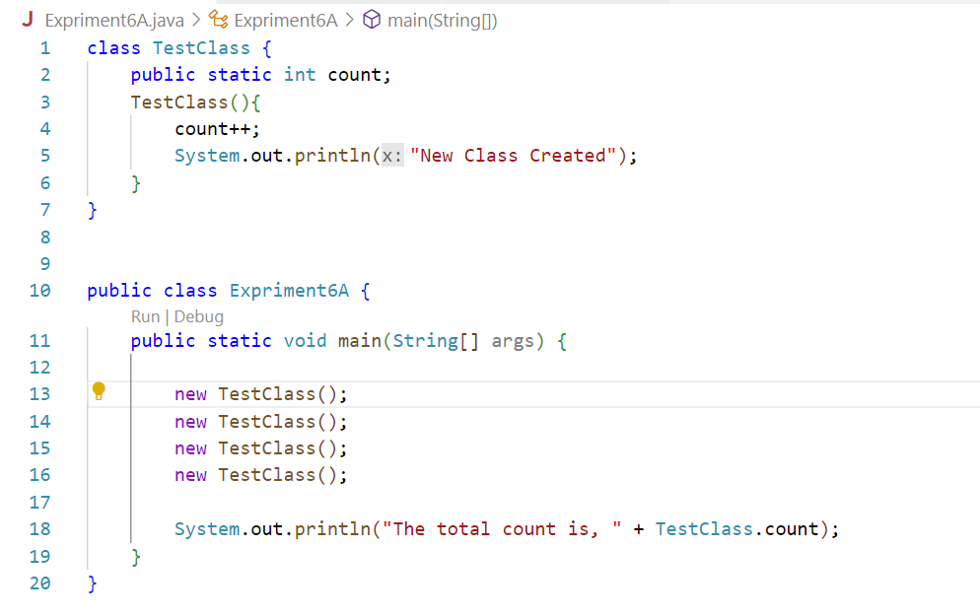

**Output:**

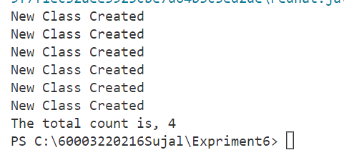

b. WAP to display area of square and rectangle using the concept of overloaded constructor (use

parameterized, non-parameterized and copy constructor).

**Code:**

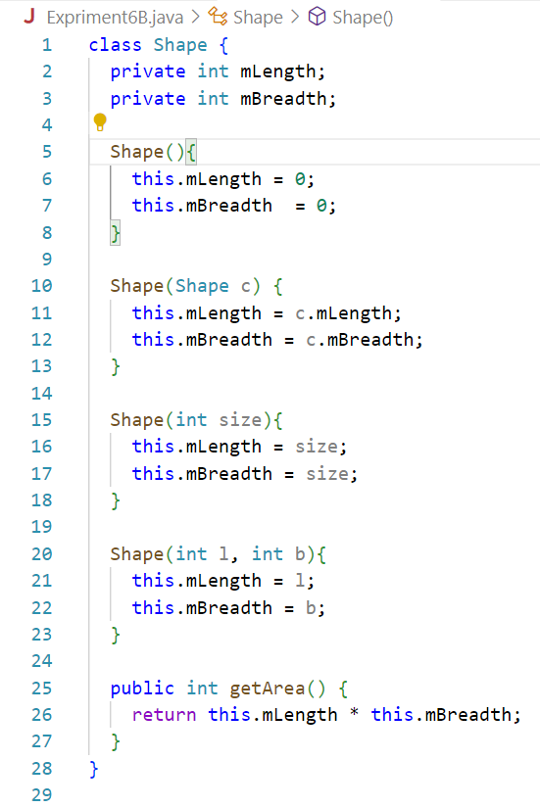

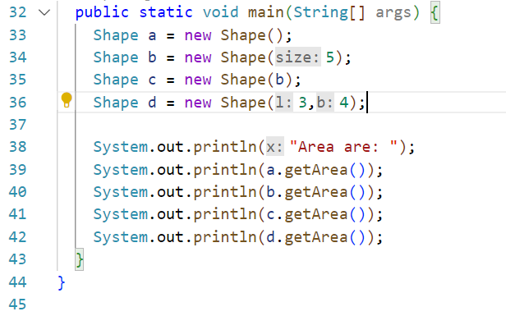

**Output:**

